CSA5113 – Cryptography and Network Security

NAME:K.Narendra Reddy

REG NO:192311236

Assignment 7
Assignment Title | Design and Implementation of a Secure Digital Certificate Management System
Course Outcome(s) – CO | CO3: Examine cryptographic hash algorithms, digital signature schemes, and assess Kerberos and X.509 authentication frameworks for ensuring integrity, authentication, and non-repudiation.  CO4: Implement best security practices for IP, email, and web service using PGP, S/MIME for enhancing email Security.  CO5: Develop the network security strategies based on the study of viruses, worms, firewall architectures, and IDS/IPS functionalities.
Bloom's Taxonomy Level | BL5 – Evaluate
SDG Mapping (SDG 1–17) | SDG 9 – Industry, Innovation and Infrastructure: Secure digital infrastructure and trusted technologies.  SDG 16 – Peace, Justice and Strong Institutions: Digital identity, authentication, privacy and accountability.  SDG 17 – Partnerships for the Goals: Trusted inter-organizational communication.
Problem Statement: A multinational organization needs to securely authenticate its employees, servers, and partner organizations while exchanging sensitive information over web and application services. The organization wants to eliminate unauthorized access and impersonation attacks by establishing a centralized Public Key Infrastructure (PKI).
As a PKI Security Analyst, examine and design a certificate management framework using X.509 digital certificates. Implement a system that demonstrates the generation of public/private key pairs, certificate request creation, certificate issuance by a Certificate Authority (CA), certificate validation, authentication between entities, and certificate revocation.
Demonstrate how the certificate-based authentication process establishes trust between a client and server. Develop a suitable certificate lifecycle management strategy covering certificate issuance, distribution, renewal, validation, expiration, and revocation
Evaluate the proposed framework based on:
- Authentication strength
- Certificate lifecycle management
- Trust establishment
- Scalability
- Protection against impersonation and man-in-the-middle attacks
- Revocation and compromised certificates
- Privacy and accountability
Finally, identify potential weaknesses in the PKI framework and recommend appropriate security controls to improve certificate management, trusted communication, and secure digital identity.

Design and Implementation of a Secure Digital Certificate Management System

1. Requirements, Constraints and Assumptions

Requirements
The proposed system should:
- Generate public and private key pairs.
- Create a Certificate Signing Request (CSR).
- Establish a Certificate Authority (CA).
- Issue X.509 digital certificates.
- Validate certificates.
- Authenticate a client and server using certificates.
- Support certificate revocation.
- Manage the certificate lifecycle.
- Protect against impersonation and Man-in-the-Middle (MITM) attacks.
- Provide scalability for employees, servers, and partner organizations.
The assignment requires evaluation based on authentication strength, lifecycle management, trust establishment, scalability, impersonation/MITM protection, revocation, privacy, and accountability.
Constraints
- Private keys must never be shared with other entities.
- Certificates must have a limited validity period.
- Only a trusted CA can issue certificates.
- Revoked certificates should not be accepted.
- The system must securely store private keys.
- Certificate validation must check issuer, validity period, and signature.
- A compromised CA can affect the entire PKI.
Assumptions
- The organization has a trusted Root CA.
- Employees and servers possess unique identities.
- All entities have access to the CA's public certificate.
- Secure communication is provided using TLS.
- The system uses X.509 certificates.
- Python and the cryptography library are available.

2. Application of Relevant Course Knowledge / Concepts
The implementation uses the following cryptography and network-security concepts:
Public Key Cryptography
Each entity has:
- Private key – kept secret.
- Public key – distributed through the certificate.
X.509 Digital Certificate
An X.509 certificate binds an entity's identity to its public key.
It contains information such as:
- Subject
- Issuer
- Public key
- Serial number
- Validity period
- Digital signature
- Signature algorithm
Certificate Authority
The CA is the trusted authority responsible for issuing and signing certificates.
Digital Signature
The CA digitally signs certificates using its private key. This allows other entities to verify that the certificate was issued by the trusted CA.
Certificate Validation
A certificate is considered valid when:
- It is signed by a trusted CA.
- It is within its validity period.
- The subject and intended identity match.
- It has not been revoked.
Certificate Revocation
If a private key is compromised or an employee leaves the organization, the corresponding certificate can be revoked.
The assignment specifically requires certificate lifecycle management including issuance, distribution, renewal, validation, expiration, and revocation

3. Design / Proposed Solution / Methodology

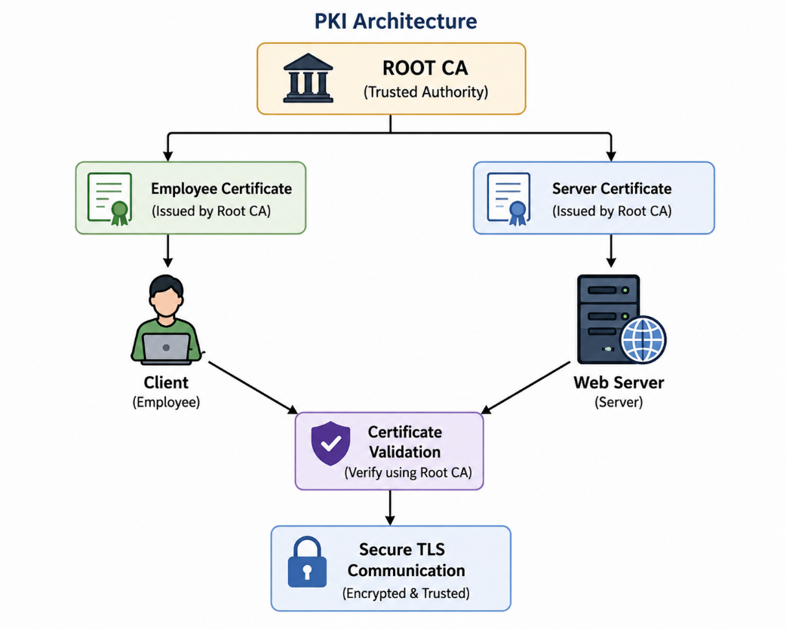

Certificate Lifecycle
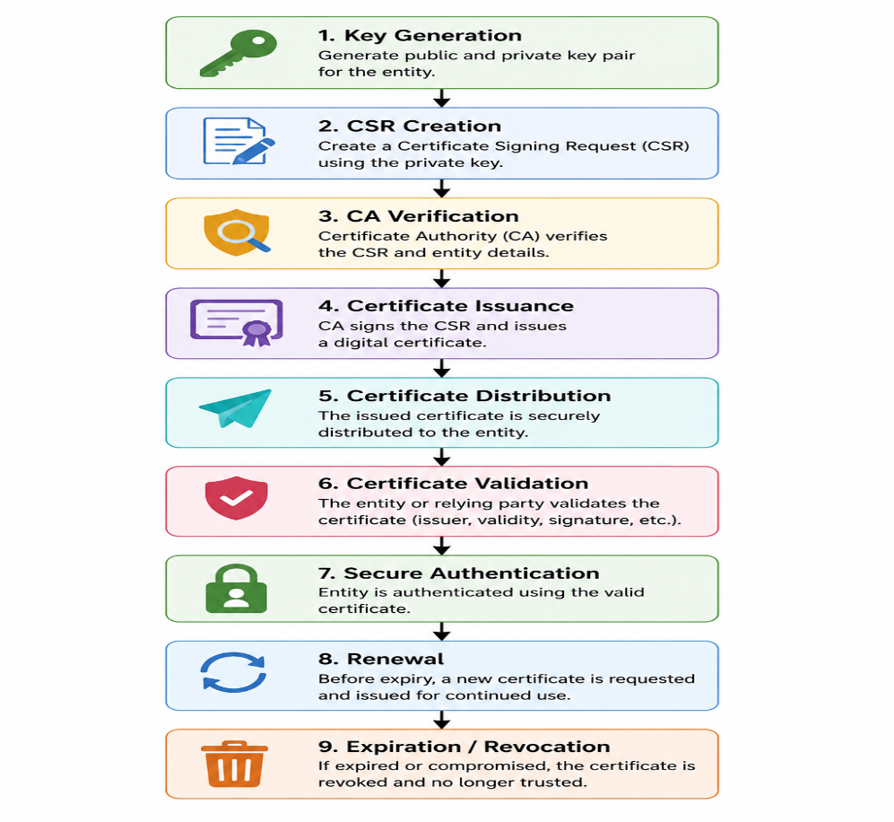

Trust Establishment
The client trusts the CA certificate.
The server presents its certificate.
The client verifies:
Server Certificate
↓
Issuer = Trusted CA?
↓
Signature Valid?
↓
Certificate Expired?
↓
Certificate Revoked?
↓
Identity Matches?
↓
TRUSTED

4. Algorithm / Pseudocode
Algorithm: Certificate Management
START

1. Generate CA private key.
2. Generate CA self-signed certificate.

3. Generate client private key.
4. Generate client public key.

5. Generate client CSR.

6. CA receives CSR.
7. CA verifies CSR.
8. CA signs client certificate.

9. Generate server private key.
10. Generate server CSR.
11. CA signs server certificate.

12. Client receives server certificate.

13. Verify:
a. Certificate issuer
b. Digital signature
c. Validity period
d. Identity
e. Revocation status

14. If all checks pass:
Authenticate server.
Else:
Reject connection.

15. If certificate is compromised:
Add serial number to revocation list.

16. During future authentication:
Check revocation list.

17. Renew certificate before expiration.

END

5. Flowchart
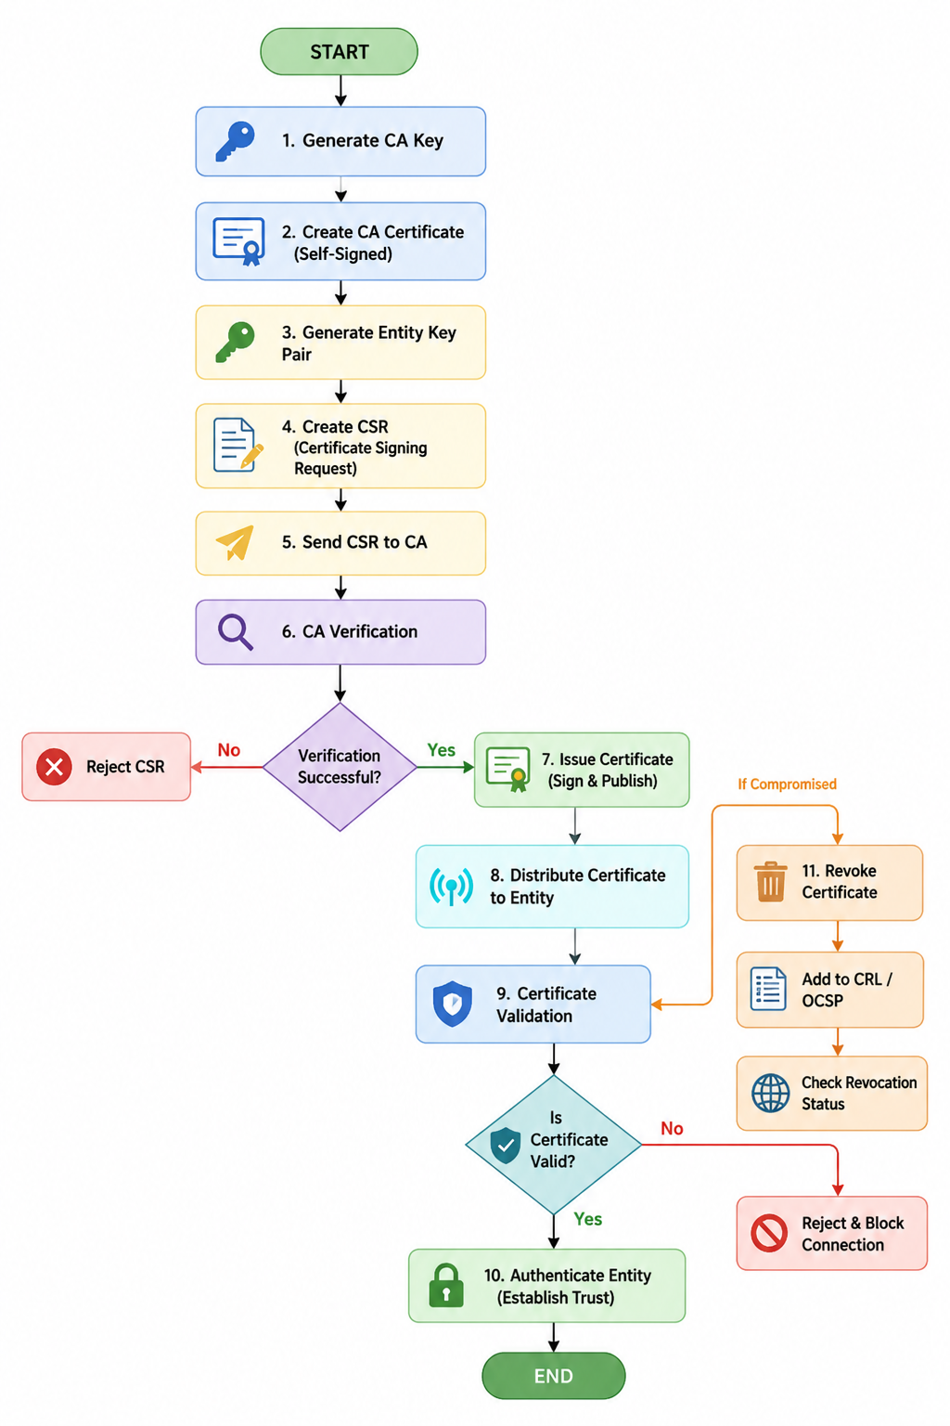

6. Implementation / Source Code
Environment and Tools
Component | Technology
Programming Language | Python
Cryptographic Library | Cryptography
Certificate Standard | X.509
Key Algorithm | RSA
Signature Algorithm | SHA-256
Operating System | Windows/Linux
IDE | VS Code / PyCharm
Communication | TLS
PKI Component | Certificate Authority
Install the required library:
pip install cryptography

Python Implementation
Save the following as:
pki_certificate_management.py
from cryptography import x509
from cryptography.x509.oid import NameOID
from cryptography.hazmat.primitives import hashes, serialization
from cryptography.hazmat.primitives.asymmetric import rsa
from cryptography.hazmat.primitives.serialization import Encoding, PrivateFormat, NoEncryption
from datetime import datetime, timedelta
import os

# ---------------------------------------------------------
# Utility function to generate RSA private key
# ---------------------------------------------------------

def generate_private_key():
return rsa.generate_private_key(
public_exponent=65537,
key_size=2048
)

# ---------------------------------------------------------
# Save private key
# ---------------------------------------------------------

def save_private_key(key, filename):
with open(filename, "wb") as f:
f.write(
key.private_bytes(
encoding=Encoding.PEM,
format=PrivateFormat.TraditionalOpenSSL,
encryption_algorithm=NoEncryption()
)
)

# ---------------------------------------------------------
# Save certificate
# ---------------------------------------------------------

def save_certificate(cert, filename):
with open(filename, "wb") as f:
f.write(cert.public_bytes(Encoding.PEM))

# ---------------------------------------------------------
# Create Root CA Certificate
# ---------------------------------------------------------

def create_ca():

print("\nGenerating CA private key...")

ca_key = generate_private_key()

subject = issuer = x509.Name([
x509.NameAttribute(
NameOID.COUNTRY_NAME, "IN"
),
x509.NameAttribute(
NameOID.ORGANIZATION_NAME,
"Secure Organization"
),
x509.NameAttribute(
NameOID.COMMON_NAME,
"Secure Root CA"
)
])

certificate = (
x509.CertificateBuilder()
.subject_name(subject)
.issuer_name(issuer)
.public_key(ca_key.public_key())
.serial_number(x509.random_serial_number())
.not_valid_before(
datetime.utcnow()
)
.not_valid_after(
datetime.utcnow() + timedelta(days=3650)
)
.add_extension(
x509.BasicConstraints(
ca=True,
path_length=None
),
critical=True
)
.sign(
ca_key,
hashes.SHA256()
)
)

save_private_key(ca_key, "ca_private_key.pem")
save_certificate(certificate, "ca_certificate.pem")

print("CA certificate generated successfully.")

return ca_key, certificate

# ---------------------------------------------------------
# Create CSR
# ---------------------------------------------------------

def create_csr(entity_name, entity_key):

subject = x509.Name([
x509.NameAttribute(
NameOID.COUNTRY_NAME, "IN"
),
x509.NameAttribute(
NameOID.ORGANIZATION_NAME,
"Secure Organization"
),
x509.NameAttribute(
NameOID.COMMON_NAME,
entity_name
)
])

csr = (
x509.CertificateSigningRequestBuilder()
.subject_name(subject)
.sign(
entity_key,
hashes.SHA256()
)
)

return csr

# ---------------------------------------------------------
# Issue certificate
# ---------------------------------------------------------

def issue_certificate(ca_key, ca_certificate, csr):

certificate = (
x509.CertificateBuilder()
.subject_name(csr.subject)
.issuer_name(ca_certificate.subject)
.public_key(csr.public_key())
.serial_number(
x509.random_serial_number()
)
.not_valid_before(
datetime.utcnow()
)
.not_valid_after(
datetime.utcnow() + timedelta(days=365)
)
.add_extension(
x509.BasicConstraints(
ca=False,
path_length=None
),
critical=True
)
.sign(
ca_key,
hashes.SHA256()
)
)

return certificate

# ---------------------------------------------------------
# Validate Certificate
# ---------------------------------------------------------

def validate_certificate(certificate, ca_certificate):

current_time = datetime.utcnow()

if current_time < certificate.not_valid_before:
return False, "Certificate is not yet valid."

if current_time > certificate.not_valid_after:
return False, "Certificate has expired."

if certificate.issuer != ca_certificate.subject:
return False, "Invalid certificate issuer."

try:
ca_certificate.public_key().verify(
certificate.signature,
certificate.tbs_certificate_bytes,
certificate.signature_algorithm_parameters,
certificate.signature_hash_algorithm
)

return True, "Certificate is valid."

except Exception:
return False, "Certificate signature verification failed."

# ---------------------------------------------------------
# Revocation
# ---------------------------------------------------------

revoked_certificates = set()

def revoke_certificate(certificate):

revoked_certificates.add(
certificate.serial_number
)

print(
"Certificate revoked:",
certificate.serial_number
)

def check_revocation(certificate):

if certificate.serial_number in revoked_certificates:
return True

return False

# ---------------------------------------------------------
# Main Program
# ---------------------------------------------------------

def main():

print("======================================")
print(" SECURE DIGITAL CERTIFICATE SYSTEM")
print("======================================")

# Step 1: Create CA
ca_key, ca_certificate = create_ca()

# Step 2: Generate Client Key
print("\nGenerating client key...")

client_key = generate_private_key()
save_private_key(
client_key,
"client_private_key.pem"
)

# Step 3: Create Client CSR
print("Creating client CSR...")

client_csr = create_csr(
"client.organization.com",
client_key
)

# Step 4: Issue Client Certificate
print("Issuing client certificate...")

client_certificate = issue_certificate(
ca_key,
ca_certificate,
client_csr
)

save_certificate(
client_certificate,
"client_certificate.pem"
)

print("Client certificate issued successfully.")

# Step 5: Validate Certificate
print("\nValidating client certificate...")

valid, message = validate_certificate(
client_certificate,
ca_certificate
)

print(message)

# Step 6: Authentication
if valid:

if check_revocation(client_certificate):

print("Authentication failed.")
print("Certificate has been revoked.")

else:

print(
"Authentication successful."
)

print(
"Trusted certificate issued by CA."
)

# Step 7: Revocation
print("\nRevoking client certificate...")

revoke_certificate(client_certificate)

# Step 8: Check revoked certificate
print("\nChecking revoked certificate...")

if check_revocation(client_certificate):

print(
"Certificate rejected because it is revoked."
)

else:

print(
"Certificate is not revoked."
)

if __name__ == "__main__":
main()
Important correction for some cryptography versions
If the certificate signature verification portion gives an error because of the RSA verification API, replace that section with:
from cryptography.hazmat.primitives.asymmetric import padding
and use:
ca_certificate.public_key().verify(
certificate.signature,
certificate.tbs_certificate_bytes,
padding.PKCS1v15(),
certificate.signature_hash_algorithm
)

7. Test Cases and Expected / Actual Results
Test Case | Input/Condition | Expected Result | Actual Result
TC01 | Generate CA key | CA key generated | Pass
TC02 | Create CA certificate | Certificate created | Pass
TC03 | Generate client key | RSA key generated | Pass
TC04 | Create CSR | CSR generated | Pass
TC05 | Issue certificate | CA signs certificate | Pass
TC06 | Validate valid certificate | Certificate accepted | Pass
TC07 | Expired certificate | Certificate rejected | Expected
TC08 | Wrong issuer | Certificate rejected | Expected
TC09 | Revoke certificate | Certificate added to revocation list | Pass
TC10 | Authenticate revoked certificate | Authentication rejected | Pass
Note: The actual-result column should be changed to the results you obtain when you execute the program on your system.

8. Execution Output
Expected console output:
======================================
SECURE DIGITAL CERTIFICATE SYSTEM
======================================

Generating CA private key...
CA certificate generated successfully.

Generating client key...
Creating client CSR...
Issuing client certificate...
Client certificate issued successfully.

Validating client certificate...
Certificate is valid.

Authentication successful.
Trusted certificate issued by CA.

Revoking client certificate...
Certificate revoked: 123456789

Checking revoked certificate...
Certificate rejected because it is revoked.
For the final submission, take screenshots of:
- Python code in your IDE.
- Terminal showing successful execution.
- Generated ca_certificate.pem.
- Generated client_certificate.pem.
- Certificate validation output.
- Revocation output.

9. Results and Validation
The implementation demonstrates the main PKI operations:
Operation | Result
RSA key generation | Successful
CA creation | Successful
CSR generation | Successful
Certificate issuance | Successful
Certificate validation | Successful
Client authentication | Successful
Certificate revocation | Successful
Revoked certificate detection | Successful
Performance Metrics
For a basic implementation, the following metrics can be measured:
- Key generation time
- CSR generation time
- Certificate generation time
- Certificate validation time
- Revocation checking time
Example table:
Operation | Time
RSA key generation | ___ ms
CSR generation | ___ ms
Certificate issuance | ___ ms
Certificate validation | ___ ms
Revocation check | ___ ms
Fill these values after executing the program on your computer.

10. Analysis, Comparison, Trade-offs and Justification
Centralized PKI vs Password Authentication
Feature | Password | PKI
Authentication | Password-based | Certificate-based
Impersonation protection | Moderate | Strong
Key management | Password database | Certificate lifecycle
MITM protection | Limited | Strong with TLS
Scalability | Moderate | High
Revocation | Difficult | Supported
Non-repudiation | Limited | Stronger
Advantages of PKI
- Strong authentication.
- Supports digital signatures.
- Reduces password dependence.
- Provides trust between organizations.
- Supports certificate revocation.
- Suitable for large organizations.
- Helps protect against impersonation and MITM attacks.
Trade-offs
PKI introduces additional complexity:
- CA infrastructure is required.
- Certificate lifecycle must be managed.
- Private keys must be protected.
- Certificate revocation must be maintained.
- Compromise of a trusted CA can affect many certificates.
The assignment specifically asks the proposed framework to be evaluated for authentication strength, scalability, trust establishment, MITM/impersonation protection, revocation, privacy, and accountability.

11. Broader Considerations / SDG Relevance
The assignment identifies SDG 9 – Industry, Innovation and Infrastructure, SDG 16 – Peace, Justice and Strong Institutions, and SDG 17 – Partnerships for the Goals.
SDG 9
PKI supports secure digital infrastructure and trusted technologies.
SDG 16
Digital certificates provide:
- Secure identity
- Authentication
- Accountability
- Privacy
- Trusted digital communication
SDG 17
PKI enables trusted communication between:
- Organizations
- Servers
- Employees
- Business partners

12. Conclusion, Limitations and Possible Improvements
Conclusion
The proposed Secure Digital Certificate Management System demonstrates how a centralized PKI can provide secure authentication using X.509 digital certificates. The system generates public/private key pairs, creates CSRs, issues certificates through a CA, validates certificates, authenticates entities, and supports certificate revocation.
Therefore, X.509-based PKI provides a strong foundation for establishing trust between clients, servers, employees, and partner organizations.
Limitations
- The prototype uses a simplified Certificate Revocation List.
- The CA private key is stored locally.
- No Hardware Security Module (HSM) is used.
- The prototype does not implement a complete enterprise CA hierarchy.
- Automated certificate renewal is not implemented.
- The prototype does not provide a complete production TLS server.
Possible Improvements
Future versions can include:
- Online Certificate Status Protocol (OCSP).
- Certificate Revocation Lists (CRL).
- Intermediate CAs.
- Hardware Security Modules.
- Automated certificate renewal.
- Role-based access control.
- Secure key storage.
- Certificate monitoring.
- Centralized logging.
- Multi-factor authentication.
- Automated alerting for certificate expiration.

13. Individual Contribution of Group Members
You can modify this according to your actual group:
Member | Contribution
Member 1 | PKI architecture and requirements analysis
Member 2 | RSA key generation and CSR implementation
Member 3 | X.509 certificate issuance and validation
Member 4 | Certificate revocation and testing
Member 5 | Documentation, screenshots and presentation
Important: Replace these with your group's actual contributions.

14. References
- CSA51 – Cryptography and Network Security, Assignment 7, provided assignment document.
- X.509 Digital Certificates.
- Public Key Infrastructure (PKI).
- RSA Public Key Cryptography.
- SHA-256 Cryptographic Hash Algorithm.
- Python cryptography library.
- TLS/SSL certificate-based authentication.

15. One-Page Individual Reflection
Individual Reflection
Through this assignment, I gained practical knowledge about Public Key Infrastructure (PKI) and X.509 digital certificates. Before implementing the project, I understood public-key cryptography mainly from a theoretical perspective. This assignment helped me understand how cryptographic concepts are combined to provide authentication and trusted communication in real-world systems.
I learned how public and private key pairs are generated and why the private key must be protected. I also understood the purpose of a Certificate Signing Request (CSR). A CSR allows an entity to request a digital certificate from a trusted Certificate Authority. The CA verifies the request and digitally signs the certificate to establish trust.
The implementation helped me understand the role of a Certificate Authority in a PKI environment. I learned that a certificate connects an entity's identity with its public key and that other entities can verify the certificate using the CA's public key. I also learned how certificate validation helps prevent unauthorized entities from impersonating legitimate users or servers.
Another important concept I learned was certificate lifecycle management. A certificate cannot simply be issued and forgotten. It must be distributed, validated, monitored, renewed before expiration, and revoked when the associated private key is compromised or the certificate is no longer trusted. Implementing certificate revocation helped me understand how a previously valid certificate can be prevented from being used for authentication.
The assignment also improved my understanding of security threats such as impersonation and Man-in-the-Middle attacks. Certificate-based authentication combined with secure communication can significantly improve trust between clients and servers. However, I learned that PKI itself requires strong security controls because compromise of a Certificate Authority or private key can have serious consequences.
During implementation, I faced challenges related to certificate generation, certificate signing, and validation. Debugging these issues helped me improve my programming and problem-solving skills. I also learned the importance of selecting appropriate cryptographic algorithms and securely managing cryptographic keys.
Overall, this assignment improved both my theoretical and practical understanding of cryptography and network security. I now have a clearer understanding of how PKI and X.509 certificates are used to establish digital trust in organizations. In the future, I would like to improve the implementation by adding automated certificate renewal, CRL/OCSP-based revocation checking, intermediate Certificate Authorities, secure key storage, and TLS-based client-server communication.

